BANGALORE DEFENCE ACADEMY
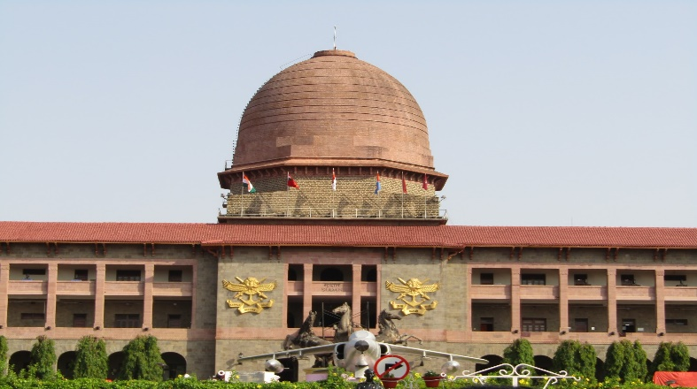 | 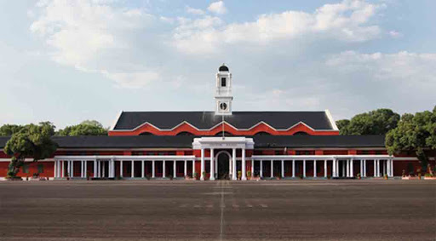 | 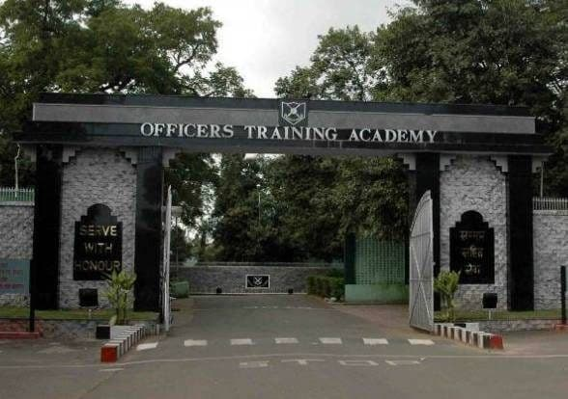
NDA | IMA | OTA

CURRENT AFFAIRS

OFFICIAL MASCOTS OF 19TH ASIAN GAMES UNVIELED
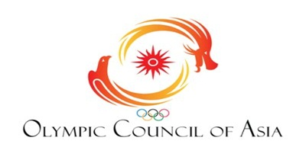 |  | The official mascots of the 19th Asian Games were unveiled at a digital launch ceremony in Hangzhou, China yesterday. The three robots, which are going to be the mascots for the 2022 Hangzhou Asian Games are collectively known as the smart triplets.  The Mascots - Congcong, Lianlian and Chenchen, which reflect the internet prowess of Hangzhou city and Zhejiang province, were unveiled at a digital ceremony in the wake of the COVID-19 pandemic that has brought the whole world to a stand still.  The Olympic Council of Asia's 19th Asian Games will be held in Hangzhou from September 10 to 25, 2022. It will be the third Asian Games to be hosted by China following Beijing in 1990 and Guangzhou in 2010, with the participation of 45 NOCs of Asia in 42 sports.
DO YOU KNOW?
The Asian Games, also known as Asiad, is a continental multi-sport event held every four years among athletes from all over Asia. The Games were regulated by the Asian Games Federation (AGF) from the first Games in New Delhi, India, until the 1978 Games. Since the 1982 Games, they have been organized by the Olympic Council of Asia (OCA), after the breakup of the Asian Games Federation. The Games are recognized by the International Olympic Committee (IOC) and are described as the second largest multi-sport event after the Olympic Games.
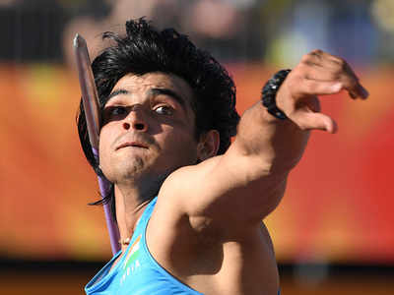 | 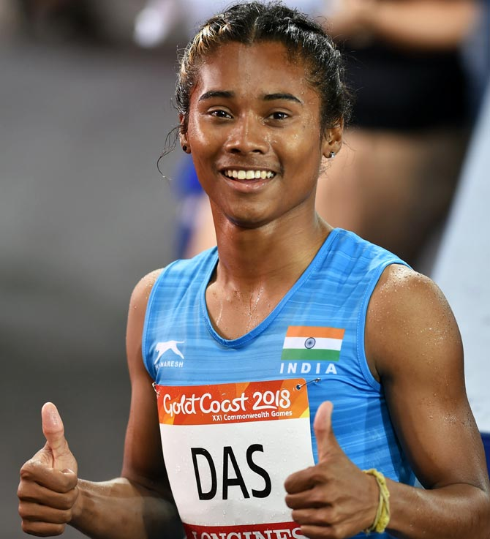 |  | 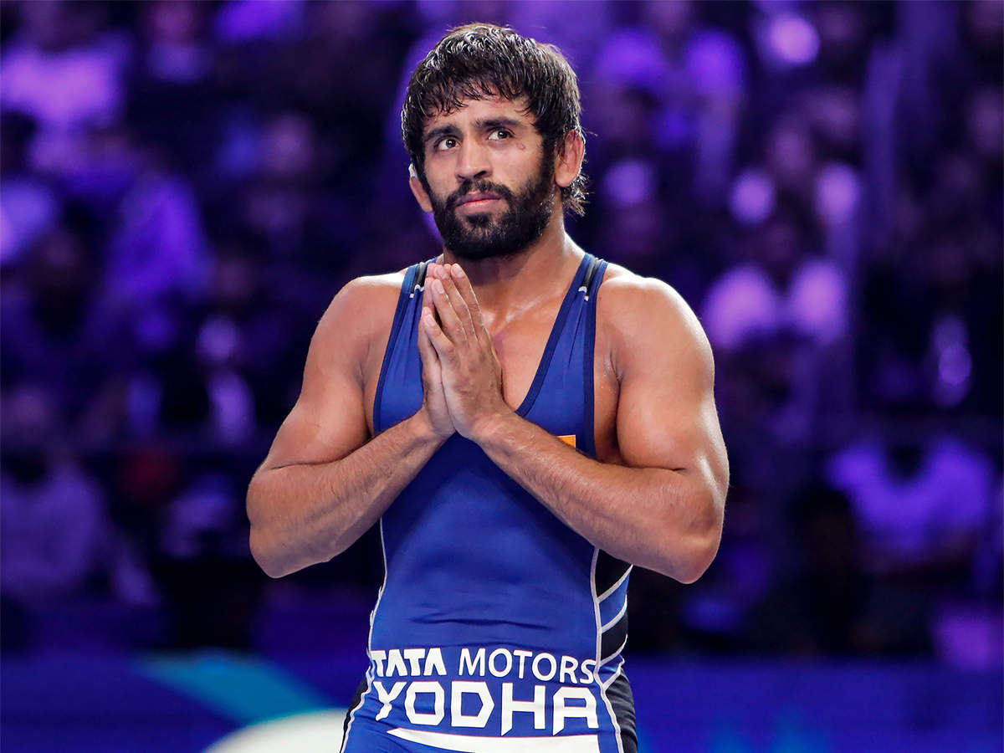
Neraj Chopra was selected as the flag-bearer at the opening ceremony for India at the 2018 Asian Games, which marked his first Asian Games appearance. | Hima Das,nicknamed the Dhing Express, is an Indian sprinter from the state of Assam. She holds the current Indian national record in 400 metres with a timing of 50.79 s that she clocked at the 2018 Asian Games in Jakarta, Indonesia. |  | Bajrang Punia (born 26 February 1994) is a freestyle wrestler from India. He competes in 65 kg weight category. He has won three medals at the World Wrestling Championships.

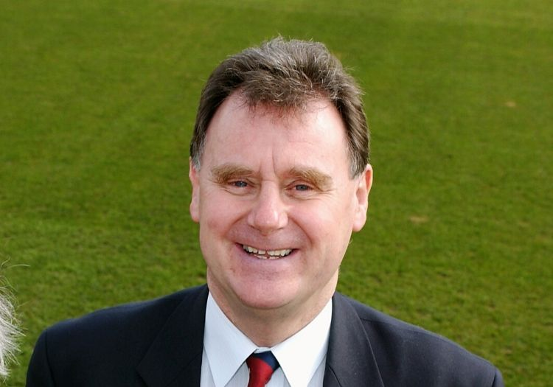 |  |  | 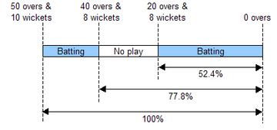

Tony Lewis, famous for Duckworth-Lewis-Stern method, dies at 78

Tony Lewis, one of the men behind the Duckworth-Lewis-Stern method used in weather-affected limited overs cricket matches, has died aged 78, the England and Wales Cricket Board announced yesterday.  Tony, alongside fellow mathematician Frank Duckworth, devised the Duckworth-Lewis method which was introduced in 1997 and adopted officially by the ICC (International Cricket Council) in 1999.  Renamed the Duckworth-Lewis-Stern Method in 2014, the mathematical formula continues to be used in rain reduced limited overs cricket games across the globe.  The method then in use was based on removing the lowest-scoring overs from each team's innings.  The formula has been criticised for not being suited to Twenty20 matches, cricket's shortest format, which came into being after Duckworth-Lewis was established.  No alternative method, however, has yet found favour with the ICC. |  |  | 68th All India Police Athletic Championship kick starts in Haryana  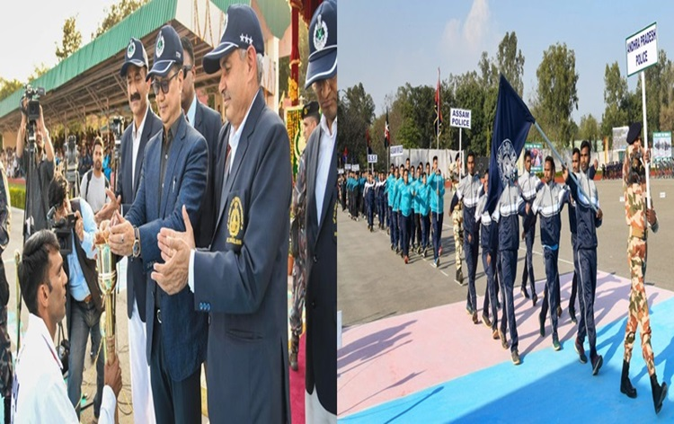@KirenRijiju  68th All India Police Athletic Championship-2019 was held at Bhanu in Panchkula District of Haryana. Union Minister of State for Youth Affairs and Sports Kiren Rijiju declared the meet open at Basic Training Centre of ITBP. Addressing the meet, Mr Rijiju said that with an aim to bring India in top 10 in the Olympics scheduled in 2028, the government has identified 15,000 plus children and started their training across 284 Sports Authority of India (SAI) training centres across the country. He said, to achieve this goal, the role of the Central Armed Police Forces (CAPFs) and State Police organisations becomes very important. Efforts shall be made to assign few games to each force so that we can get good results in Olympics after 8 years.

What are MK 54 torpedoes, AGM-84L Harpoon missiles US has cleared for sale to India?
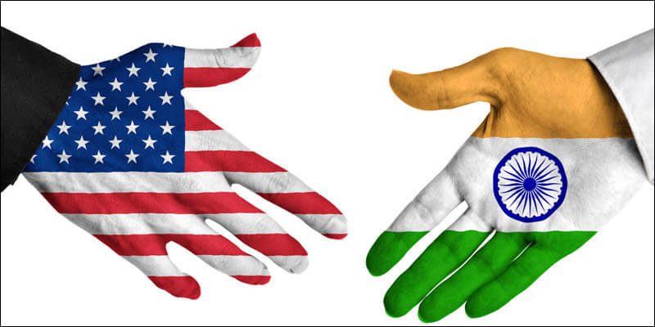
The US Department of State approved a possible Foreign Military Sale to India of 16 MK 54 all round up lightweight torpedoes and related equipment at an estimated cost of $63 million. In addition, in another deal, the US approved the possible sale to India of ten AGM-84L Harpoon Block II air-launched missiles and related equipment at an estimated cost of $92 million. | The P-8I aircraft  Boeing’s P-8s are designed for long-range anti-submarine warfare, anti-surface warfare and intelligence, surveillance and reconnaissance missions. The P-8s India version is called the P-8I, and helps the Indian Navy carry out important maritime operations.  According to Boeing, the aircraft can surpass 25,000 flight hours, and gives the Navy a significant edge in the strategically important Indian Ocean. |  |  | India currently has eight of these aircraft and is scheduled to receive four more by 2022. One of these is expected to be delivered this year. In June 2019, the Ministry of Defence placed an order for ten more of these aircraft.  The aircraft has a length of 40 meters and can fly at a speed of 789 km/hour. They are stationed at INS Rajali and a secondary station is being set up at INS Kochi.

What is the MK 54 lightweight torpedo?
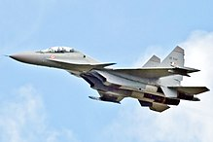  Previously, the MK 54 lightweight torpedo was known as the Lightweight Hybrid Torpedo (LHT). It weighs around 608 pounds, while its warhead weighs around 96.8 pounds and is highly explosive. These torpedoes are used by US surface ships, fixed-wing aircraft and helicopters and are their primary anti-submarine warfare weapon.  According to the US Director Operational Test and Evaluation, the primary use of this equipment is for offensive purposes when deployed by anti-submarine warfare aircraft and helicopters, and for defensive purposes when deployed by ships and against fast, deep-diving nuclear submarines and slow-moving, quiet, diesel-electric submarines |  | What are AGM-84L Harpoon Block II air-launched missiles?  As per the DSCA press release, “The Harpoon missile system will be integrated into the P-8I aircraft to conduct anti-surface warfare missions in defense of critical sea lanes while enhancing interoperability with the United States and other allied forces. India will use the enhanced capability as a deterrent to regional threats and to strengthen its homeland defense.” According to Boeing, the Harpoon was initially developed for the US Navy in 1983 and was later adapted for use on the B-52H bombers. The Harpoon was first deployed in 1977 and is an all-weather, over-the-horizon, anti-ship missile system. This missile is being used by Armed forces in over 30 countries across the world and Boeing has delivered over 7,000 Harpoon missiles to date. Further, the Harpoon missile uses GPS-aided inertial navigation to hit the designated target. Its warhead weighs over 500 pounds and is capable of delivering lethal firepower against targets, including land-based targets, coastal defence sites, surface-to-air missile sites, exposed aircraft and industrial or port facilities.

Armed forces in coronavirus outbreak battle: their role, procedures for requisition

What is the procedure?
The regulations permit civil authorities to requisition the Army for controlling law and order, maintaining essential services, assisting during natural calamities such as earthquakes, and any other type of help that may be needed by the civil authorities. The procedure for requisitioning armed forces is governed under ‘Aid to Civil Authorities’ under the guidelines laid in Instructions on Aid to the Civil Authorities by the Armed Forces, 1970; Regulations for the Army, Chapter VII, Paragraphs 301 to 327; and Manual of Indian Military Law, Chapter VII. Civil administration requests the Local Military Authority for assistance, for the maintenance of law and order, maintenance of essential services, disaster relief and other types of assistance. Armed forces can be asked to provide troops and equipment for a flag march, rescue and relief, evacuation, and immediate aid.
The current case of cheCking the spread of COVID-19 is different, as the medical aspect is predominant. These resources are being controlled centrally and judiciously, because of the requirement of doctors, equipment and facilities.

What are the tasks expected to be performed in the current situation?
Besides the specialised medical resources, which are centrally controlled, the local units are prepared for maintenance of law and order, crowd control, curfew in sensitive areas, evacuation of civilians from affected areas, provision of essential supply of electricity and water, restoration of essential services, emergency feeding and shelter, prevention of panic, prevention of theft and loot, guarding quarantine locations and detention centres, surveillance through drones aerial platforms, and other miscellaneous tasks.

In such situations, what happens to the armed forces’ primary role?
Providing aid to civil authorities, as and when called upon to do so, is a secondary task for the armed forces. It cannot replace the primary role of ensuring external security and operational preparedness. The Army recently killed five militants on the Line of Control (LoC), foiling an infiltration attempt, while losing five Special Forces soldiers in the engagement. There have been 53 ceasefire violations on the LoC which the Army has responded to. The Navy also continues to be operational on its various mission-based deployments, while taking all the precautions to prevent infection from foreign ports. Personnel at a quarantine facility in Manesar set up by the Army.

Is there a ceiling on such deployment?
No, there is no such ceiling either of duration of deployment or on the number of armed forces personnel that can be deployed to aid civil authority. The National Crisis Management Committee (NCMC), headed by the cabinet secretary, is the final authority.

Are there any templates or instances from the past that are applicable here?
The current situation is different from earlier cases such as tsunami or super-cyclone, which were natural disasters. The major difference is that specialists are the key in the current situation, and their tasks cannot be performed by general duty soldiers.

Who pays for the costs incurred by the armed forces in these roles?
The civil administration. The cost of assistance provided by the Armed Forces is recovered in accordance with the instructions contained in Appendix ‘H’ to the Pamphlet ‘Instructions on Aid to Civil Authorities by the Armed Forces 1970’. These instructions are also contained in the ADGFP letter No 9367/Reports/GS/FP2 dated 11 Jul 1994.

What is the role of the National Disaster Management Authority?
NDMA is involved in secondary follow-ups by the Home Ministry, and is not very actively involved in the current case. The roles of the Ministries of Health, Home, Civil Aviation and Defence are predominant in this case. The armed forces are aligned with them at the apex level viz NCMC. The directions are followed by execution-level coordination which is done by respective secretaries in the government.

What Armed Forces have done so far
– 6 quarantine facilities in Mumbai, Jaisalmer, Jodhpur, Hindon, Manesar and Chennai. Over 1,700 persons have been kept at these centres so far, of whom over 400 have been released. Three positive cases were referred to a hospital.
– 15 other facilities on standby, capacity of approximately 7,000. The Army runs 6 (Babina, Jhansi, Barmer, Bhopal, Kolkata, Binnaguri), IAF another 6 (Bhatinda, Hyderabad, Deolali, Kanpur, Gorakhpur, Agra), the Navy 3 (Vizagapatam, Kochi, Chilka).
– 51 armed forces hospitals are preparing dedicated COVID-19 facilities including High Dependency Units (scaled-down version of an Intensive Care Unit), and ICU beds.
– 5 testing labs at armed forces hospitals made part of national grid. These are Army Hospital (Research & Referral), Delhi Cantt; Air Force Command Hospital, Bangalore; AFMC, Pune; Command Hospital (Central Command), Lucknow; and Command Hospital (Northern Command), Udhampur. Six more hospitals to be equipped with the resources to begin COVID-19 testing.
– Special IAF flights have evacuated people and carried medical supplies. A C-17 Globemaster III has carried 15 tonnes of supplies to China and airlifted 125 persons including Indians on its return. From Iran, it brought back 58 stranded Indians. Also, C-130J Super Hercules aircraft has ferried 6.2 tonnes of medicine to Maldives. An Army Medical Corps team was deployed in Maldives between March 13-21.
– 60 tonnes of stores airlifted by IAF transport fleet has airlifted approximately to various parts of the country. Twenty-eight fixed wing and 21 helicopters are on standby.
– 6 Naval ships kept ready for assistance to neighbouring countries. Five medical teams also on standby for deployment in Maldives, Sri Lanka, Bangladesh, Nepal, Bhutan and Afghanistan.

